**EXPERIMENT NO 8**

**NAME: Shivam Pawar UID: 2019230068**

**NAME: Vishal Salvi UID: 2019230069**

**NAME: Shreyas Patel UID: 2018130037**

**CLASS: TE COMPS BATCH: C**

**Aim: Mini Project Report.**

**Theory:**

“**Mumbai Tour and Guide Management System**” is used to automate all process of the travel and tourism, which deals with search tourist place, booking hotel, contact with hotel and user details. The Mumbai Tour and Guide Management System allows the user of the system access all the details such as location, history as well as reviews, etc. Also, user can book hotel nearby tour location. The purpose of this system is to implement an online hotel reservation system for hotels, that will replace the manual method of booking for hotel rooms. The system shall take the start and end dates from the user and check for availability of rooms.

**Features:**

* **Tour Location details:** This module will give the description about tour location, history behind that location as well as images regarding place.
* **Hotel Details:** This is a simple user interface which displays the information about the hotel, its contact address and the amenities at the hotel. It also provides the rates of rooms in that hotel. This tool shall enable the user to check for information regarding the hotel and reserve rooms.
* **Registration:** For booking hotel user need to register in system
* **Make Payment:** After confirmation of hotel booking user will pay bill.
* **Reviews:** This module will display reviews of tourist place as well as hotel also.

**Tech Stack:**

* **Framework:** Django
* **Frontend:** Html, CSS, Js, Bootstrap
* **Backend:** PostgreSQL

**Framework:** Django

1. Django is a web development framework for Python which offers a standard method for fast and effective website development. It helps you to assists in building and maintaining quality web applications. It enables you to make the development process smooth and time-saving.
2. It is a high-level web framework which allows performing rapid development. The primary goal of this web framework is to create complex database-driven websites.

**Frontend:**

**HTML:**

1. **HTML**​ (HyperText Markup Language) is the most basic building block ofthe Web. It defines the meaning and structure of web content
2. "Hypertext" refers to links that connect web pages to one another, either within a single website or between websites.
3. By uploading content to the Internet and linking it to pages created by other **people, you become an active participant in the World Wide Web.**

**CSS:**

1. **CSS**​stands for​**C**​ascading​**S**​tyle​**S**​heets
2. CSS describes ​**how HTML elements are to be displayed on screen, paper,** **or in other media**
3. CSS ​**saves a lot of work**​. It can control the layout of multiple web pages all at once
4. External stylesheets are stored in ​**CSS files**

**Bootstrap:**

1. Bootstrap is a free front-end framework for faster and easier web development
2. Bootstrap includes HTML and CSS based design templates for typography, forms, buttons, tables, navigation, modals, image carousels and many other, as well as optional JavaScript plugins
3. Bootstrap also gives you the ability to easily create responsive designs.

**Backend: PostgreSQL**

PostgreSQL is an **ORDBMS** [**Open-Source Object-Relational Database Management System**]. It is used to store data securely; supporting best practices, and allow recovering them when the request is processed.

1. PostgreSQL is initially introduced **on 8th July 1996** at the **University of California**.
2. It is the first DBMS, which perform **MVCC** [**Multi-Version Concurrency Control**] feature, even before Oracle. The multi-version concurrency control attribute is known as **snapshot** isolation in Oracle.
3. It is written in **C** programming language.
4. PostgreSQL is **cross-platform** and runs on various operating systems such as **Microsoft** **Windows, UNIX, FreeBSD, Mac OS X, Solaris, HP-UX, LINUX**, and so on.
5. The PostgreSQL is the existing database for **the macOS** server.
6. PostgreSQL is also pronounced **as Post-gress-Q-L**, which is developed by the **PostgreSQL Global Development Group** (a worldwide team of volunteers), any organization or other private entity does not control it.
7. PostgreSQL will offer us the facility to add custom functions with the help of various programming languages such as **Java, C, and C++,** etc.

**Class Diagram:**

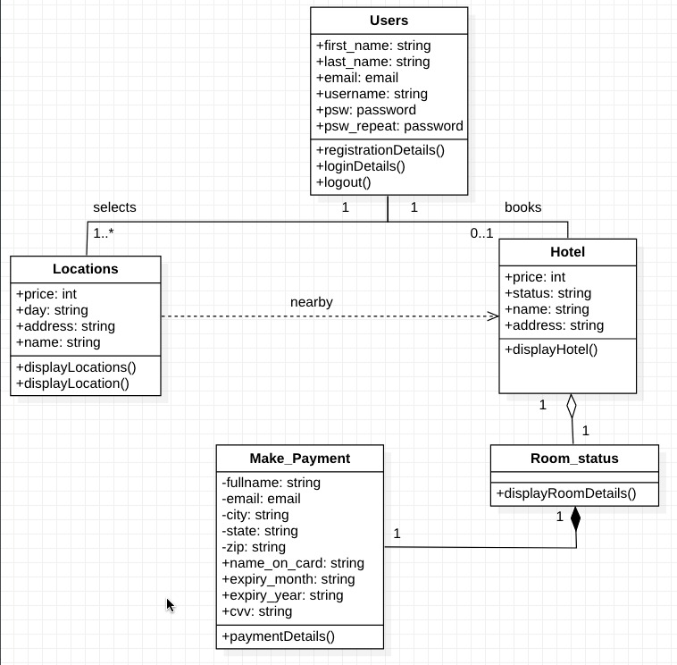

**Screenshot:**

**Run Server**

**This is the home page of Mumbai Tour and guide management.**

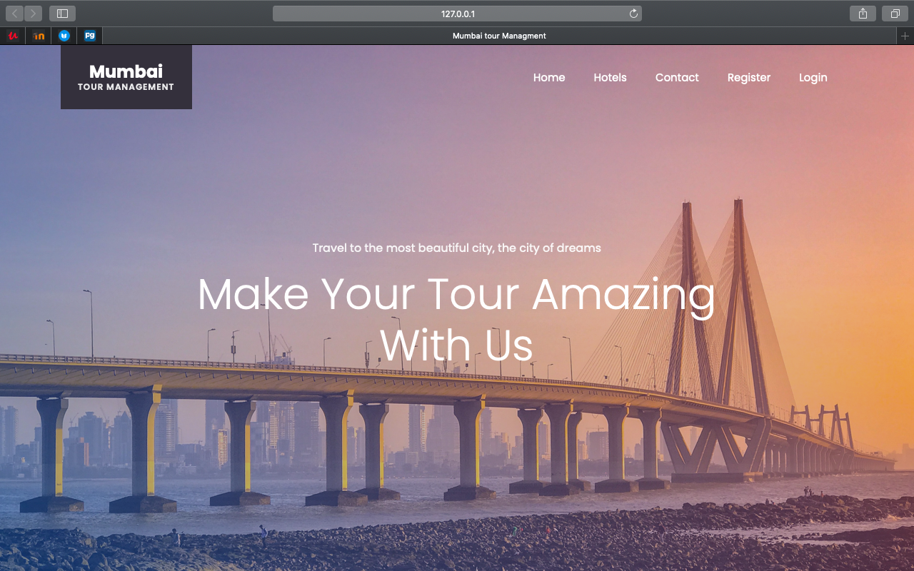

**Here user can see whatever activities, tours as well as hotel booking features in system**

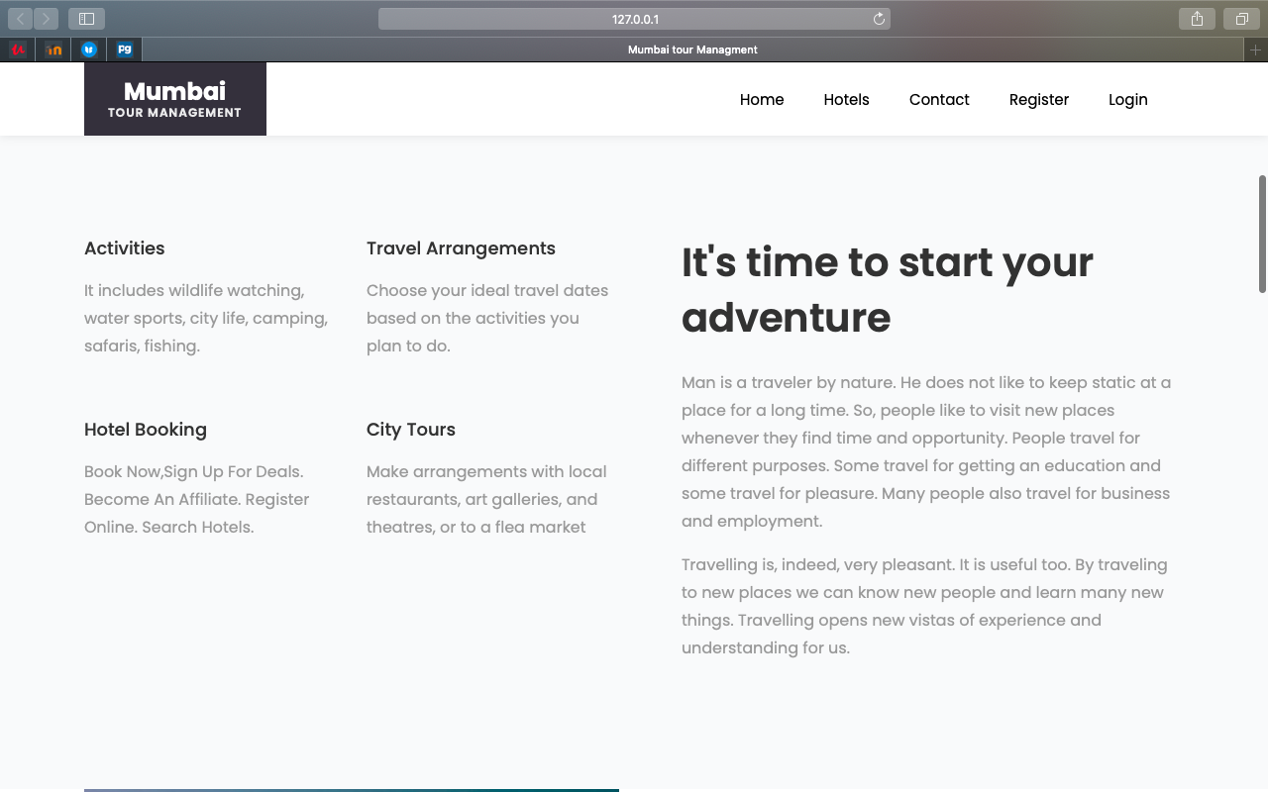

**User can see count of happy tourist and place explored by tourist**

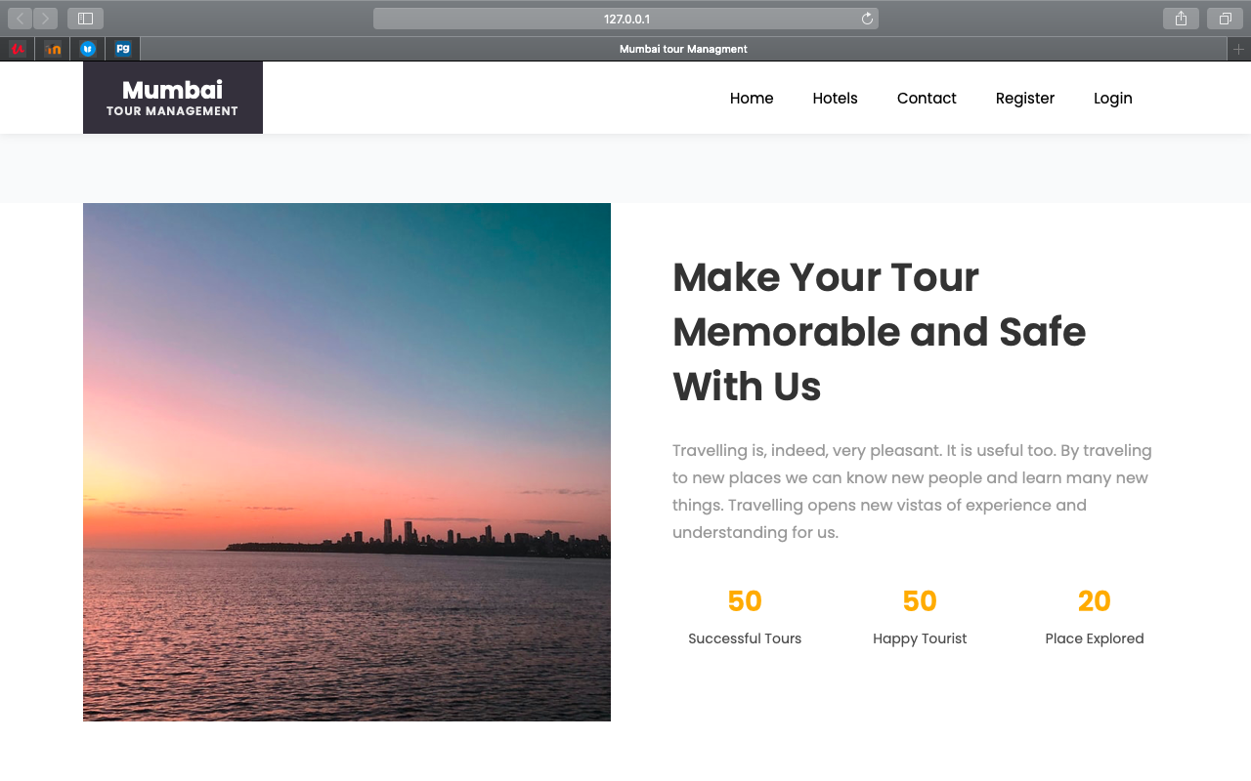

**After that user can view tour destination**

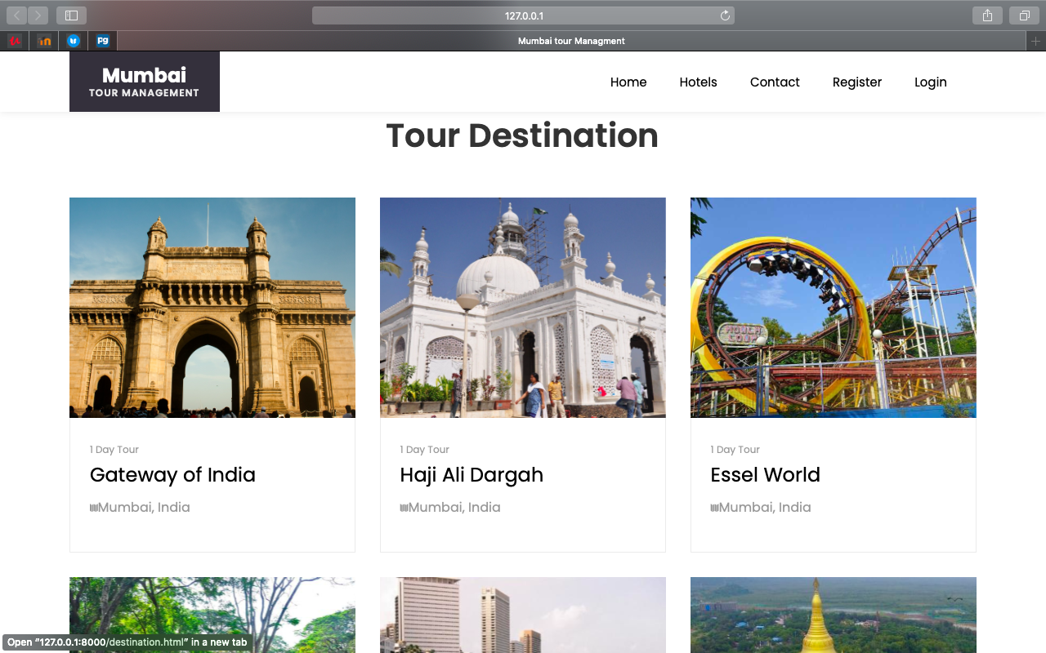

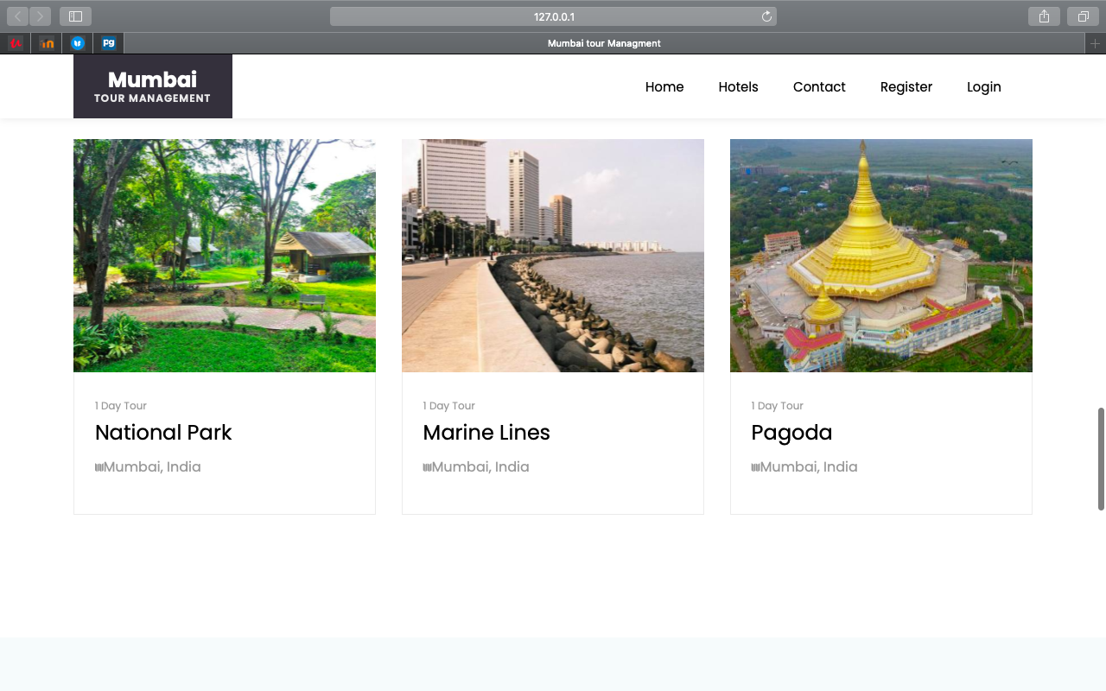

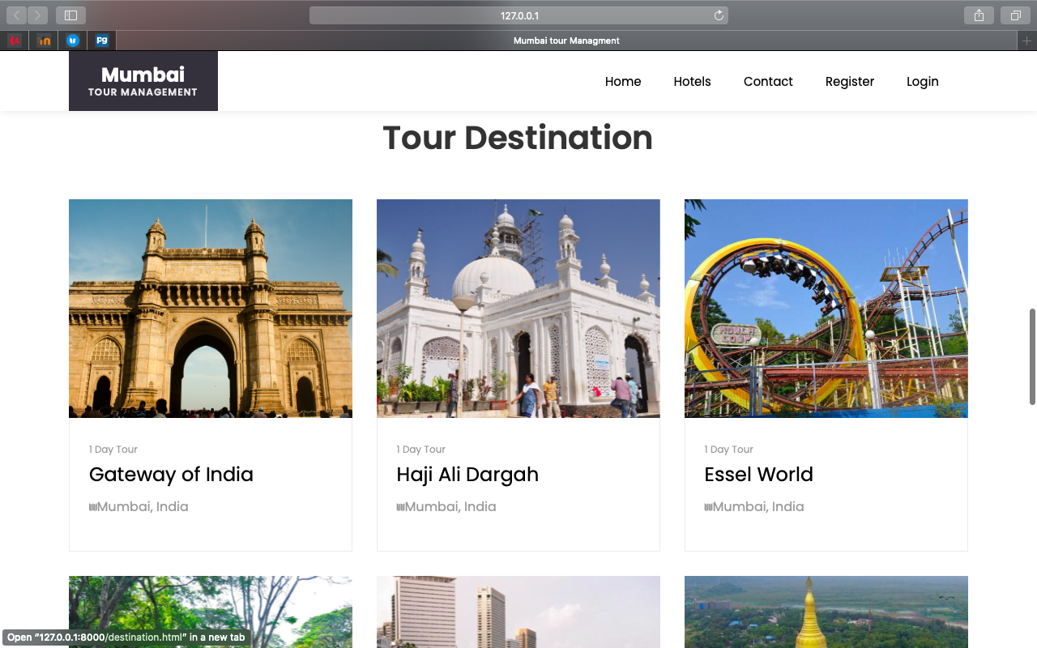

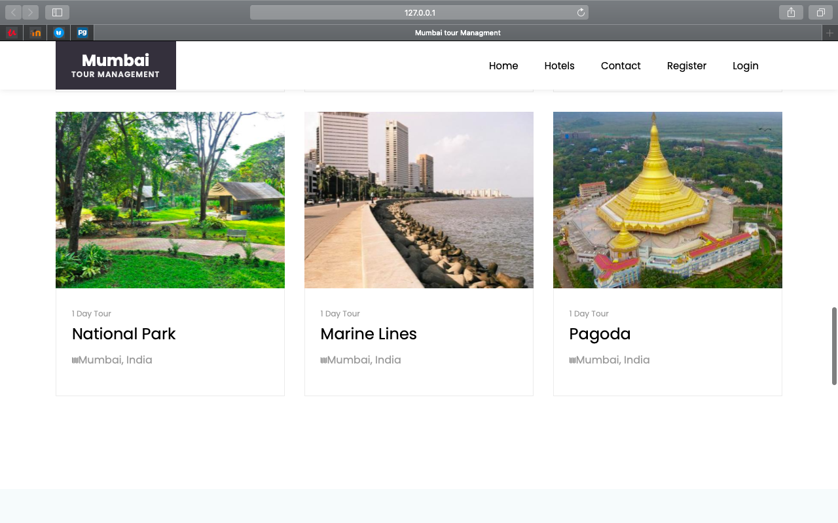

**Then user get tourist feedback**

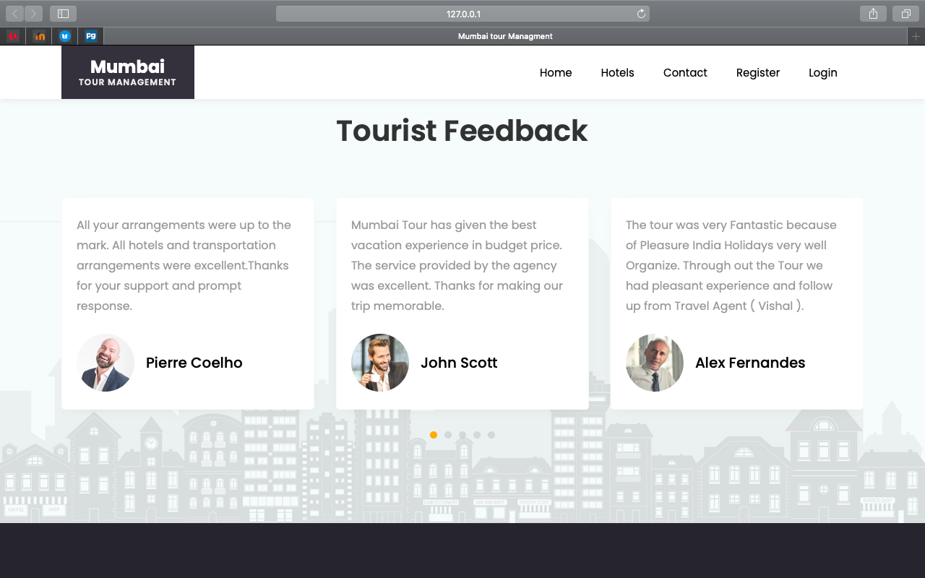

**This is Hotel Reception view**

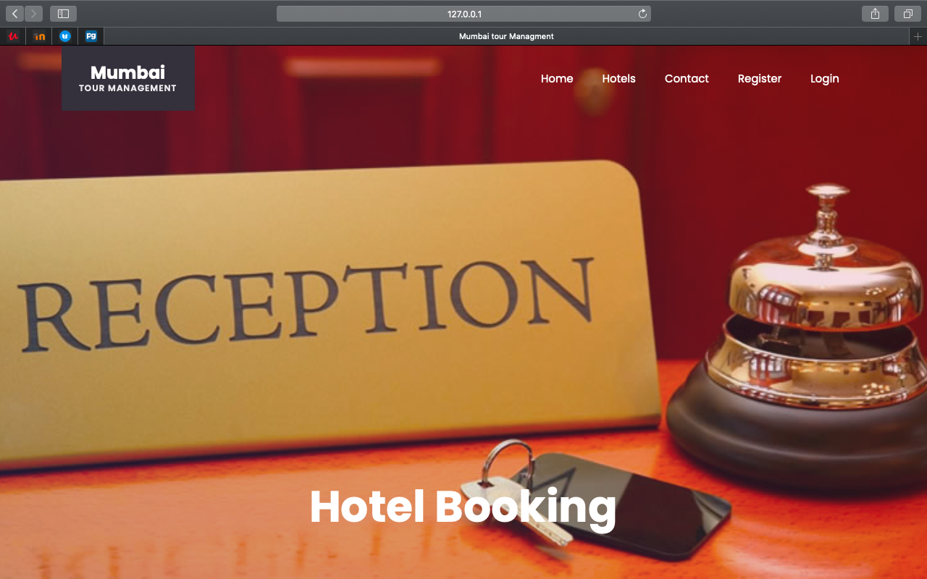

**Here, User can see Recommended Hotels which are near by tour location**

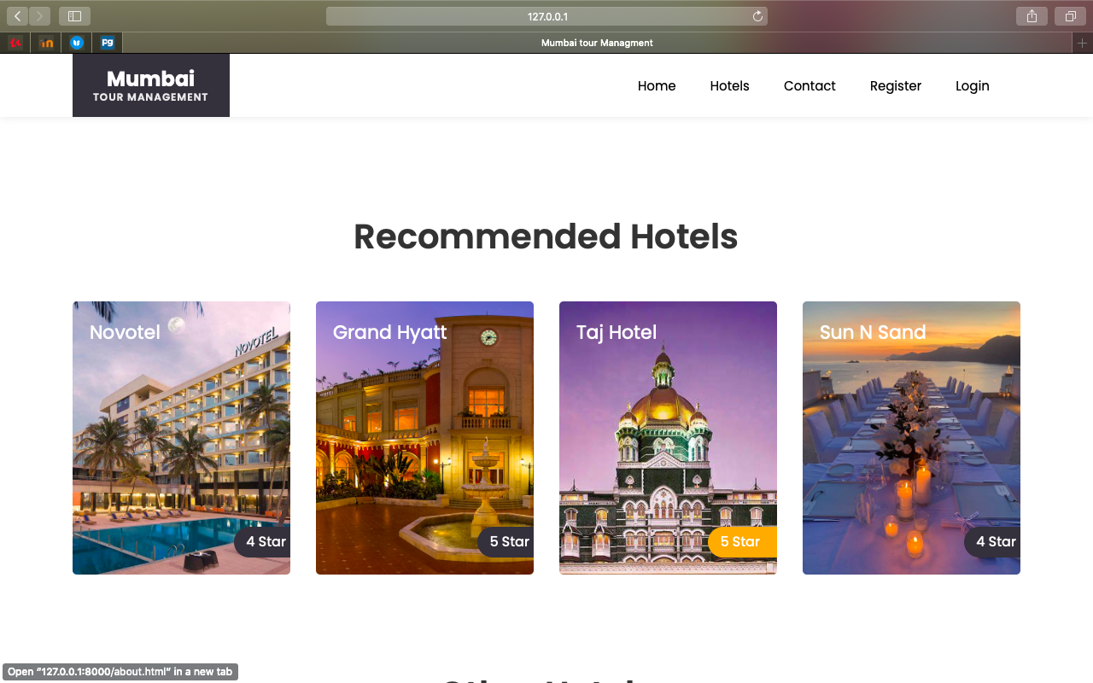

**Other Hotels**

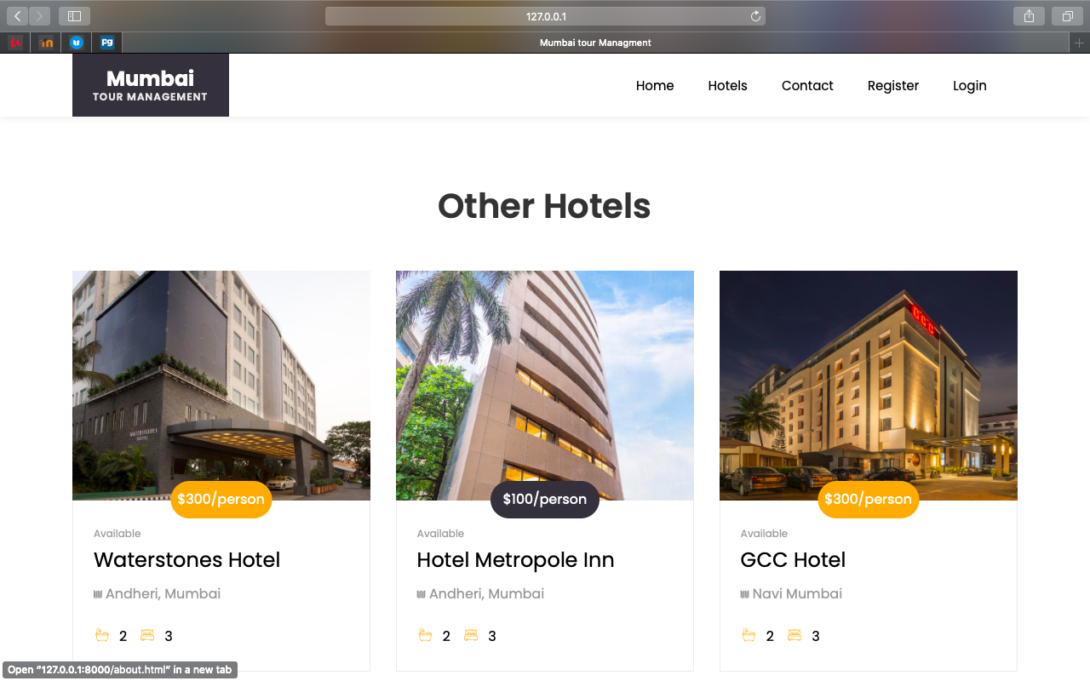

**User can view different hotels as well as details about hotel and hotel rating also**

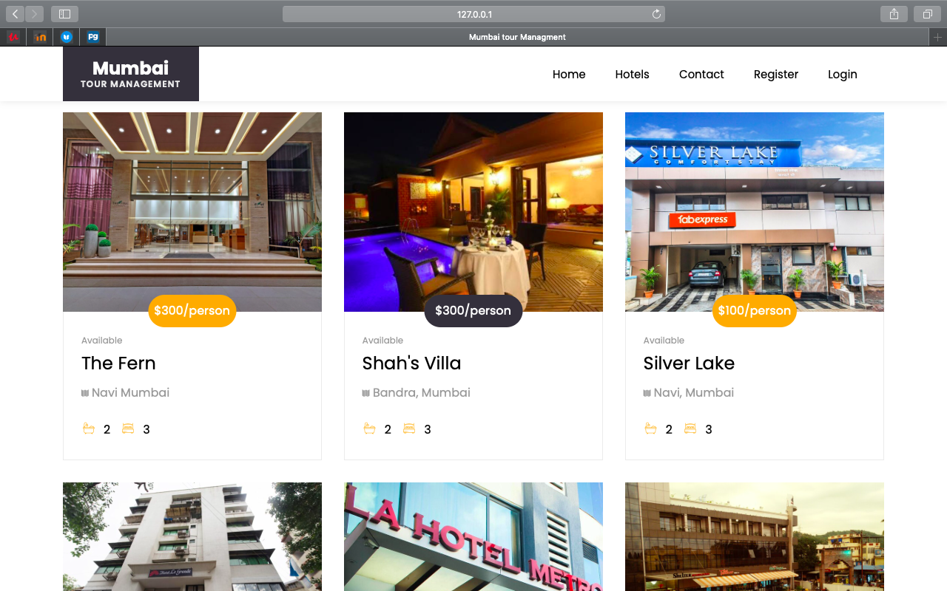

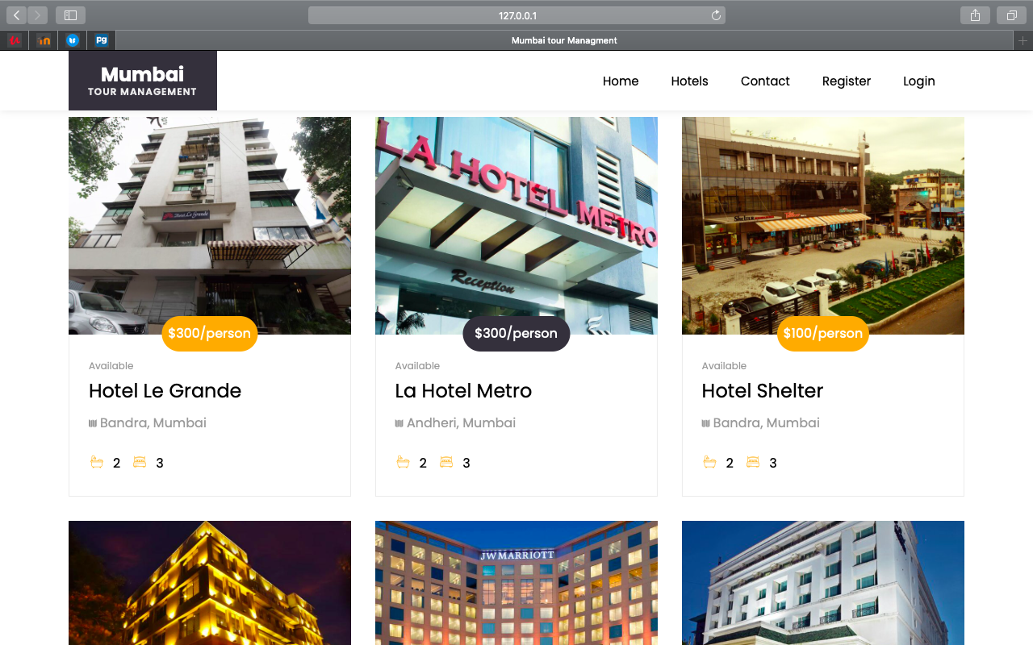

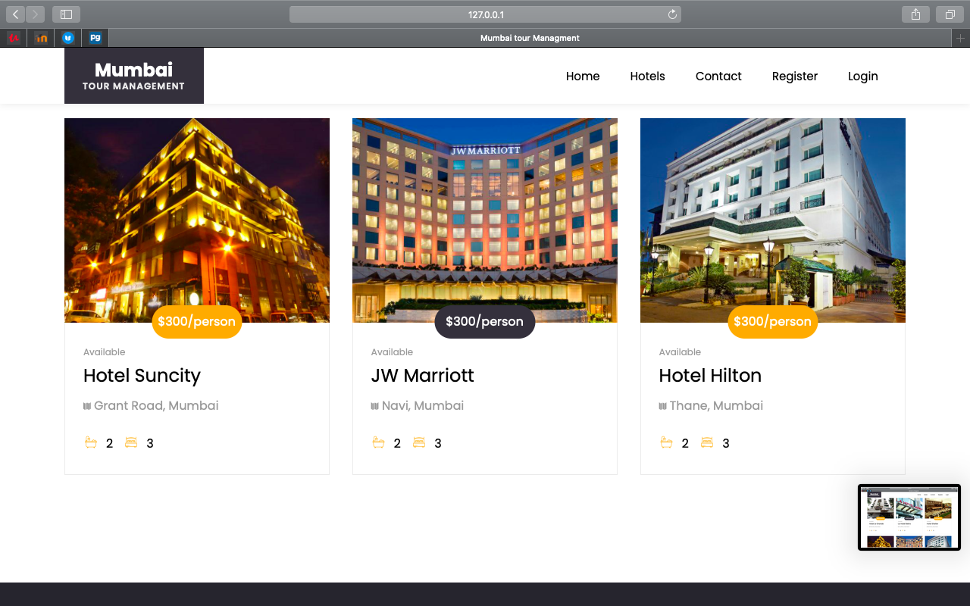

**Then, User can view of room in hotel.**

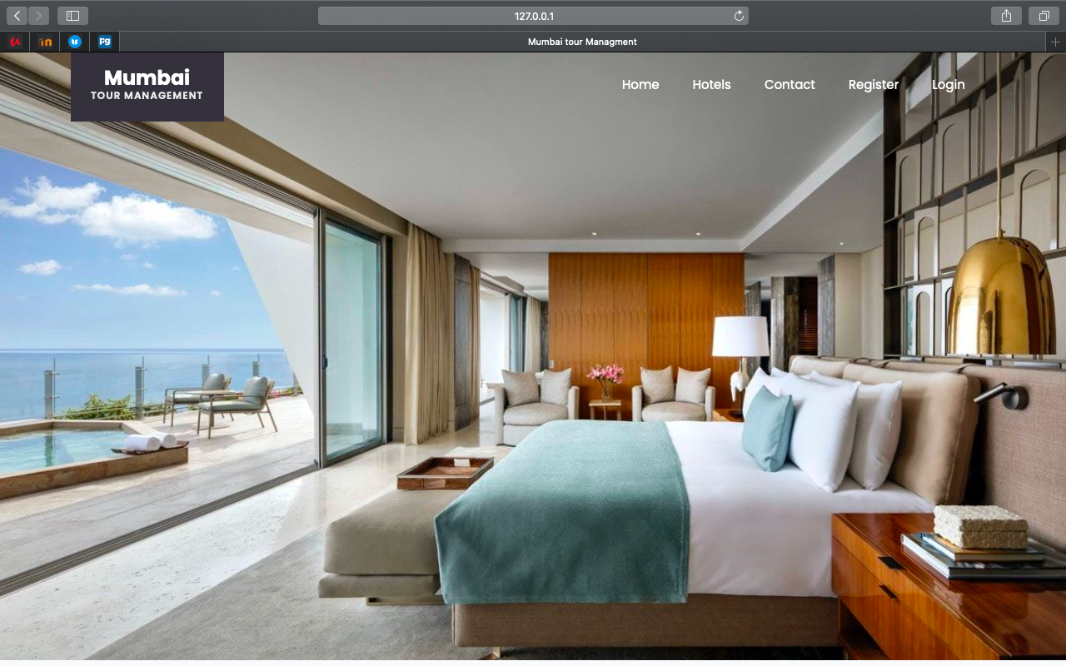

**After that can get features of hotel like Fitness centre, Tennis courts, Cafe etc.**

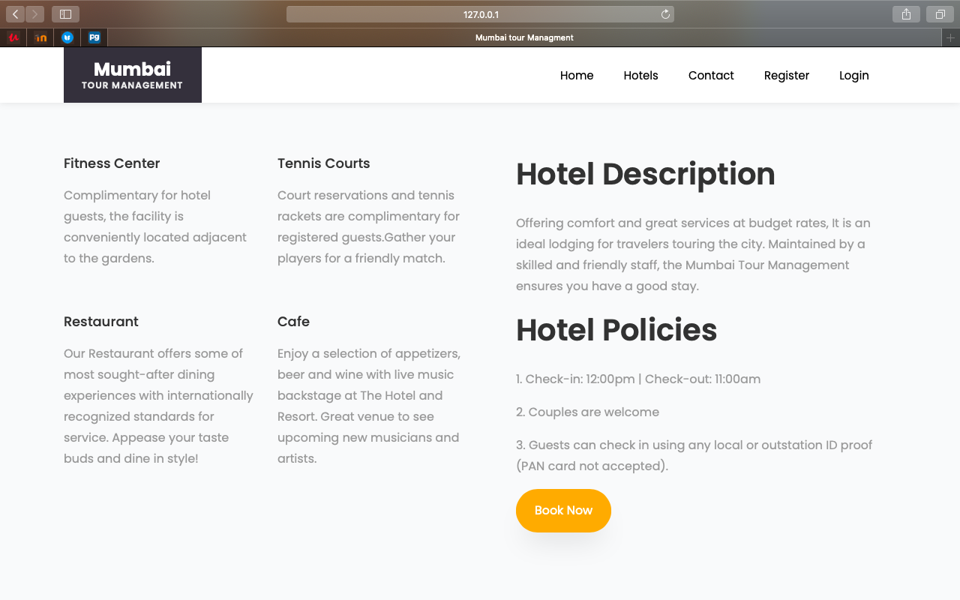

**Then user get tourist feedback**

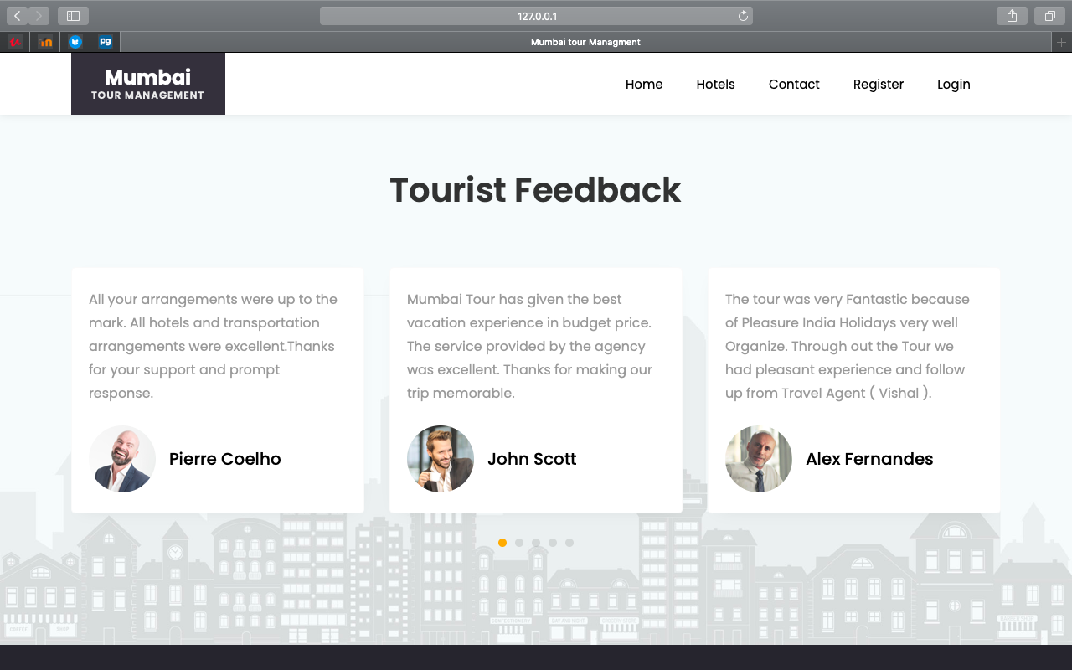

**Next is contact page**

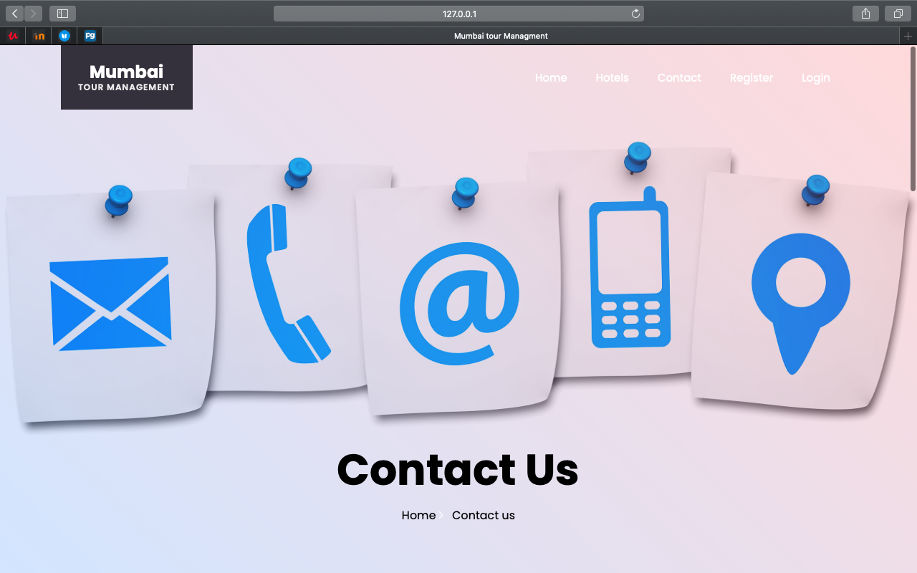

**User can send message to hotel as well as can add review.**

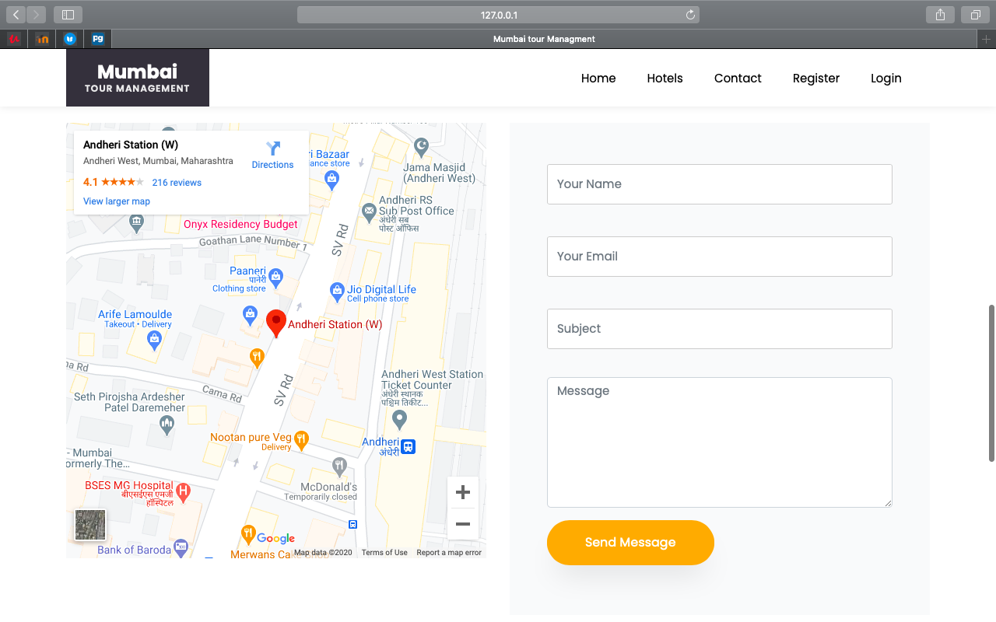

**For booking hotel user need to log in system. If user not register in the system then he/she need to register in the application.**

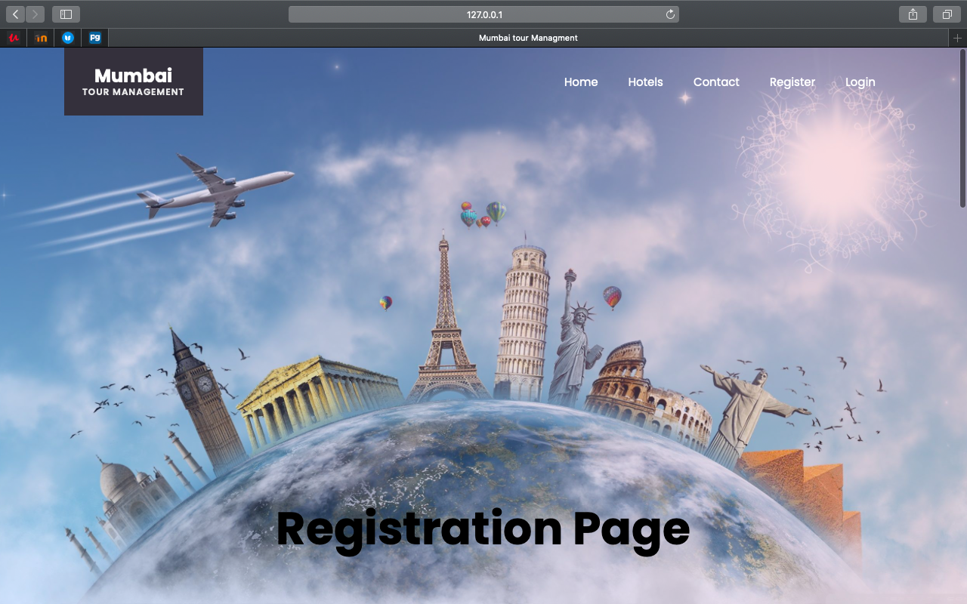

**For registration user need to fill the details like First name, Last name User Name, Email as well as Password etc.**

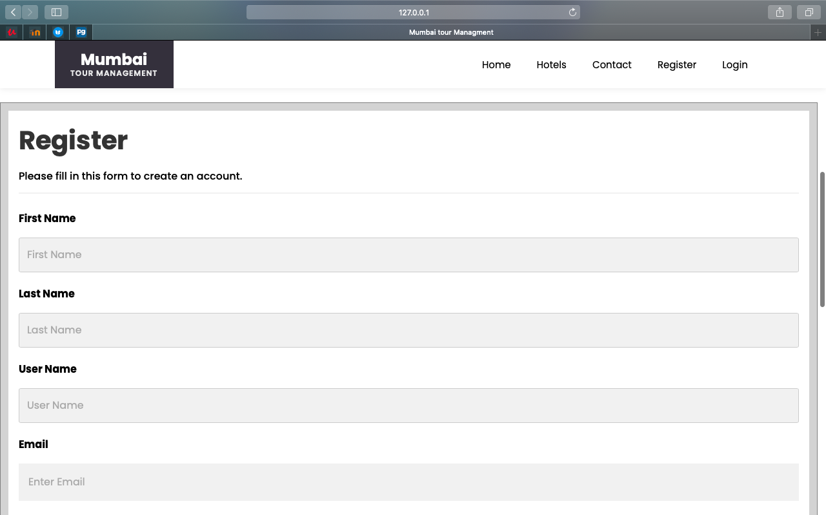

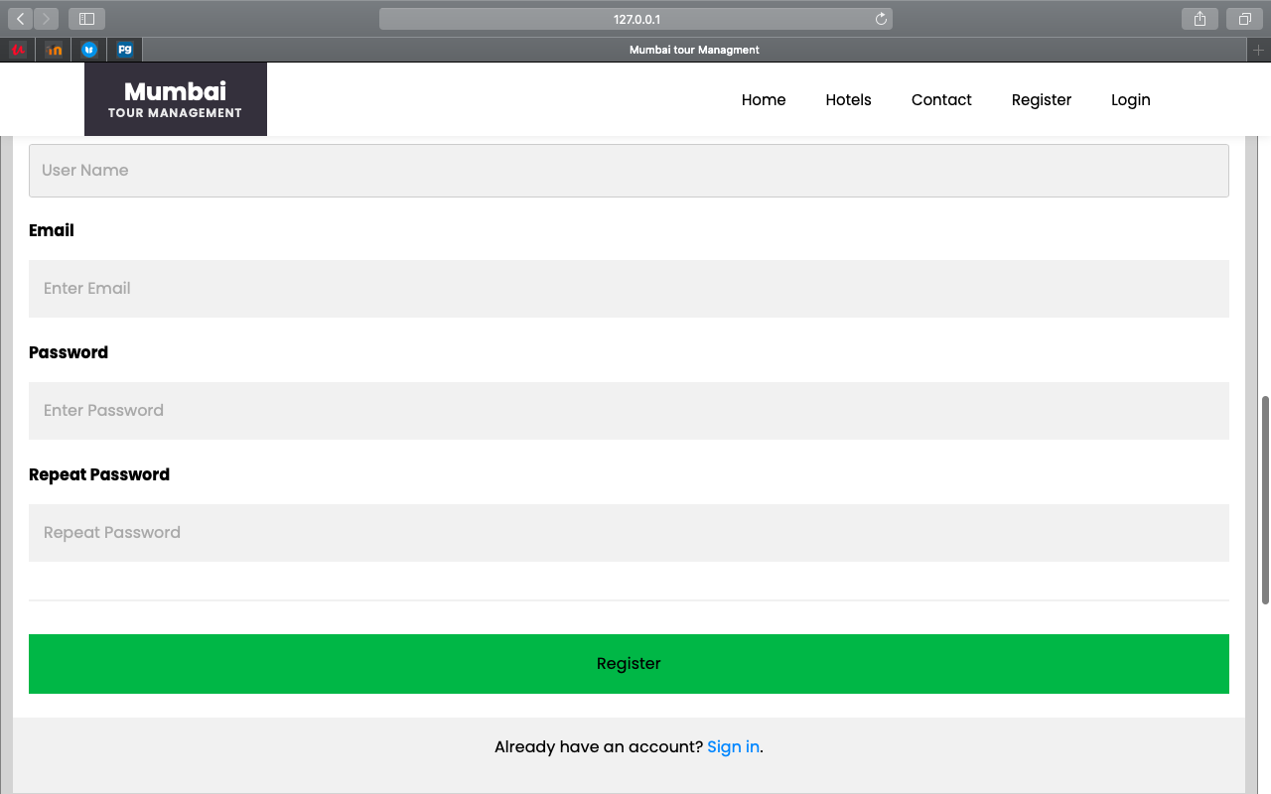

**If username is same in database or user can’t add already register username.**

If user add register username then error message prompt on screen that is Username already taken

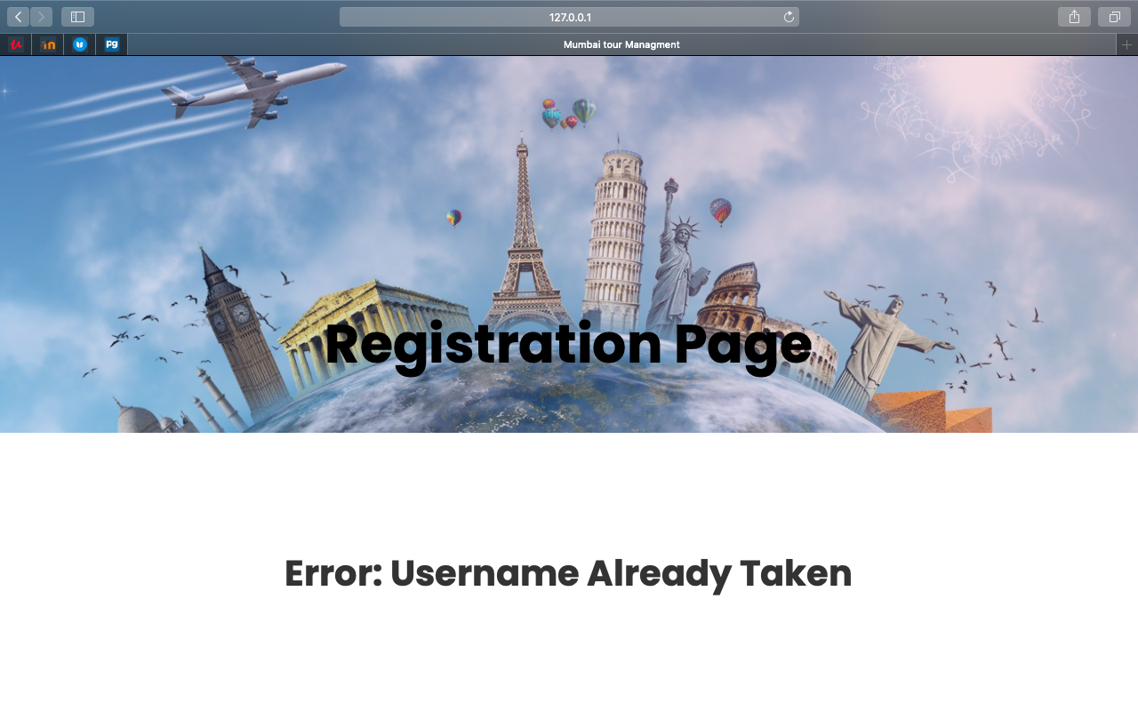

Once user register in system after that he/she can log in system for booking hotel.

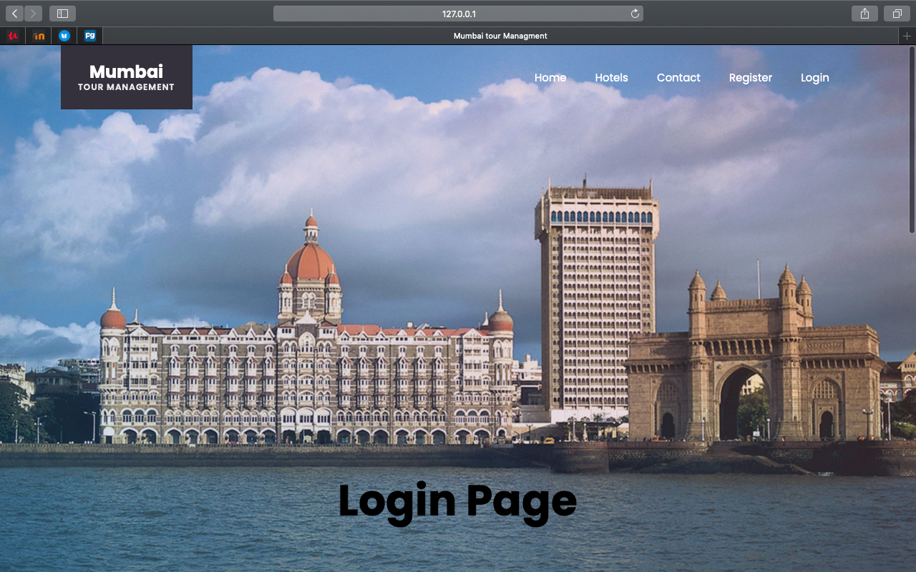

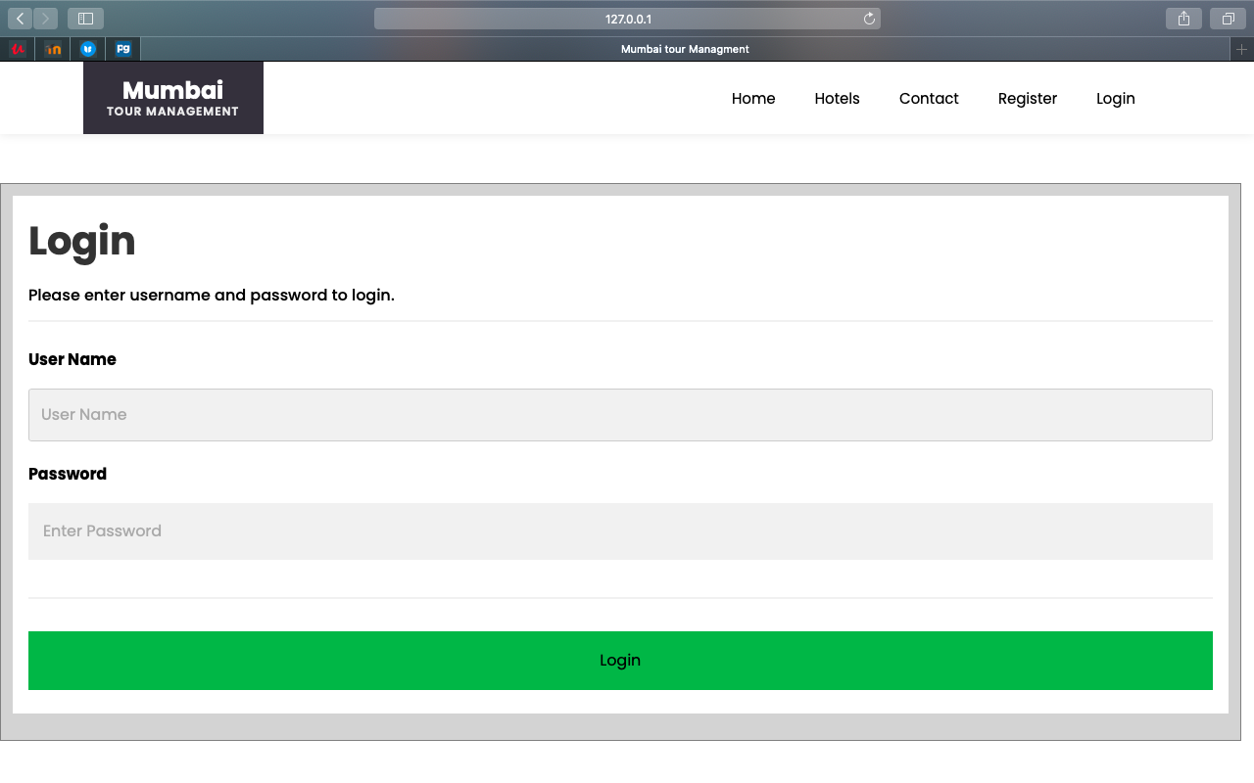

**If username and password wrong then error message will display that is Invalid credentials**

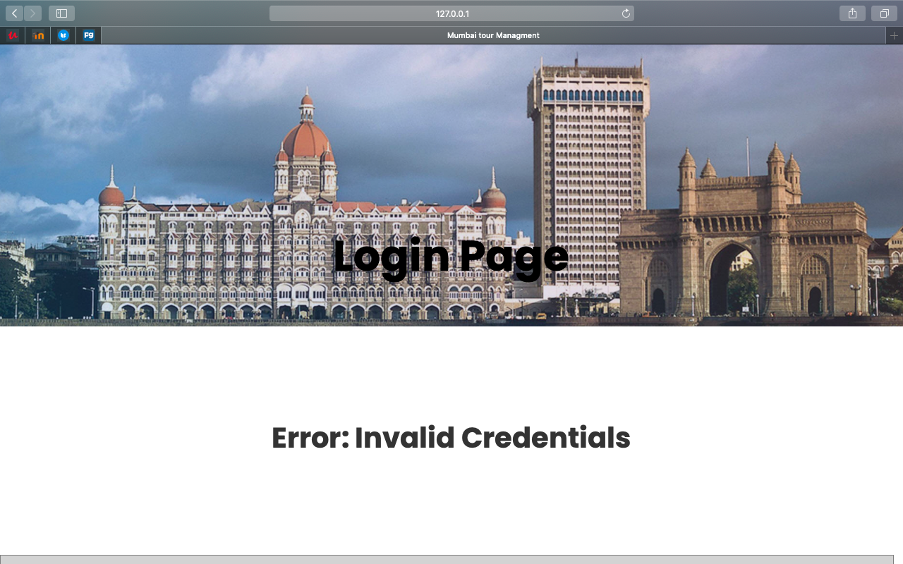

**Click on Book Now Button for booking hotel.**

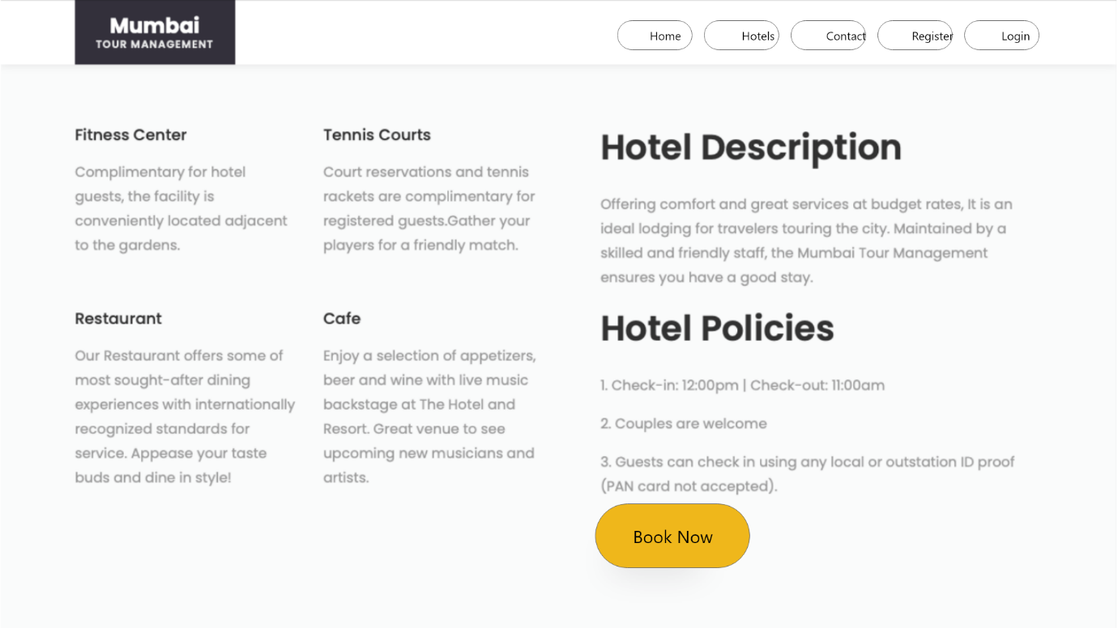

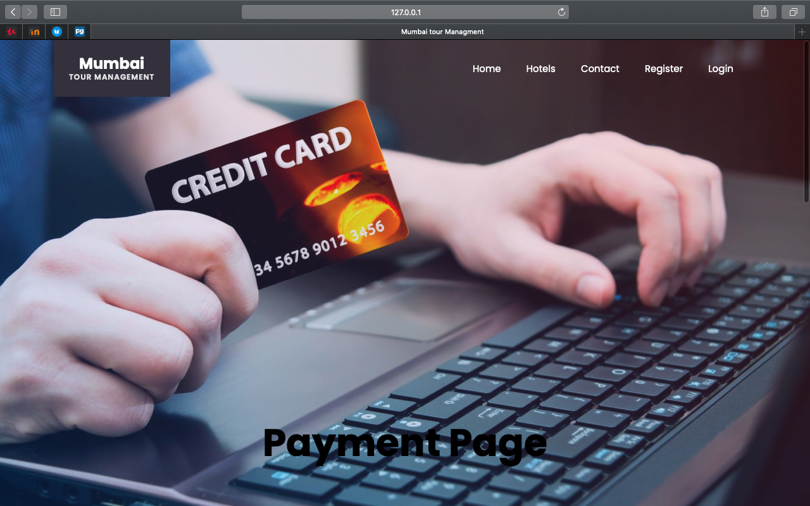

After that user need to add details about payment like city, state, zip, Name on card , Credit card number, Exp month, Exp year and CVV etc.

When user click on make payment button if all required details are correct then payment will be successful.

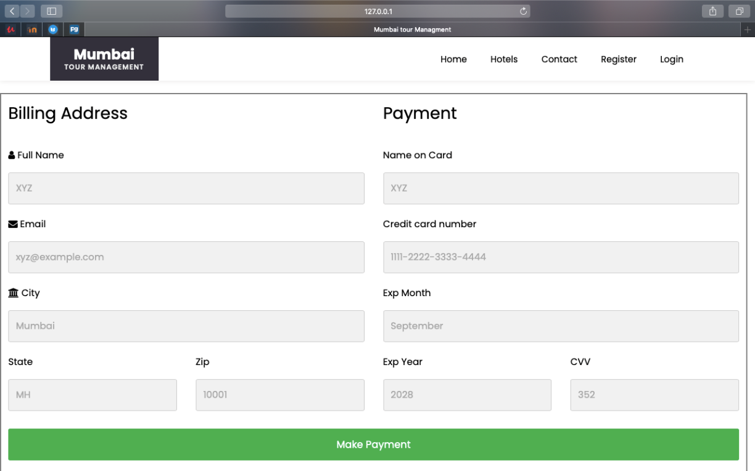

**After click on payment user booking is successful.**

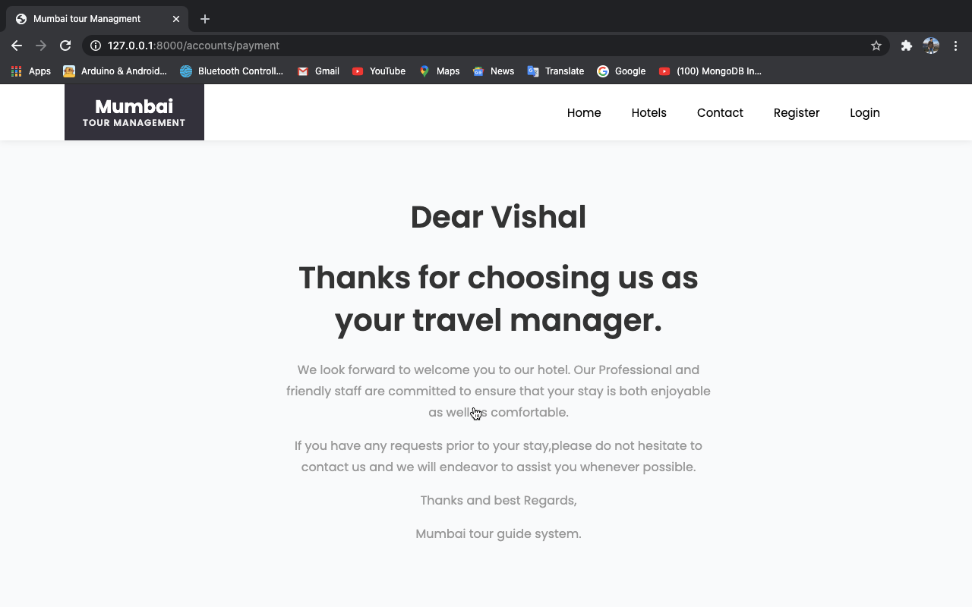

**Contact Info**

User can call to Hotel to ask some info regarding hotel.

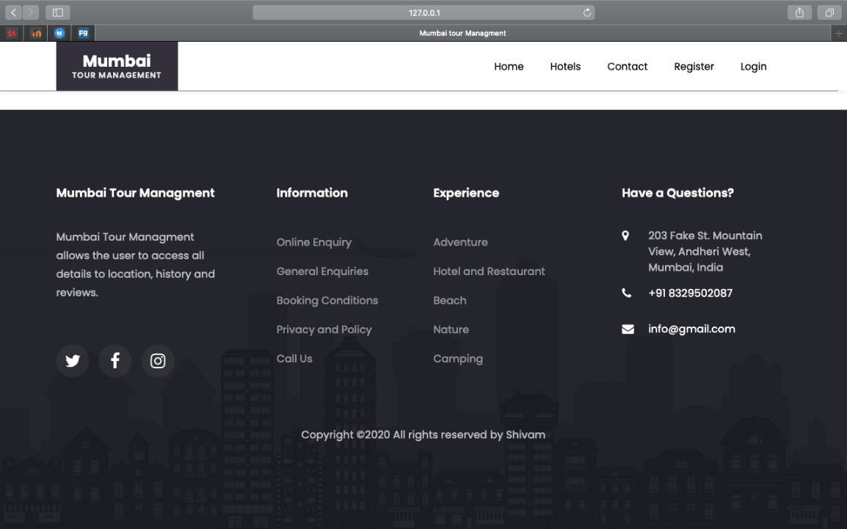

**Database:**

We are using [PostgreSQL](https://docs.djangoproject.com/en/3.1/ref/databases/#postgresql-notes) Database , below screen shot show the authentication user of the system that means the following user are register user in system.

Shivam is supervise user in system where as other are not supervise user so they indicate supervise user false while shivam has true.

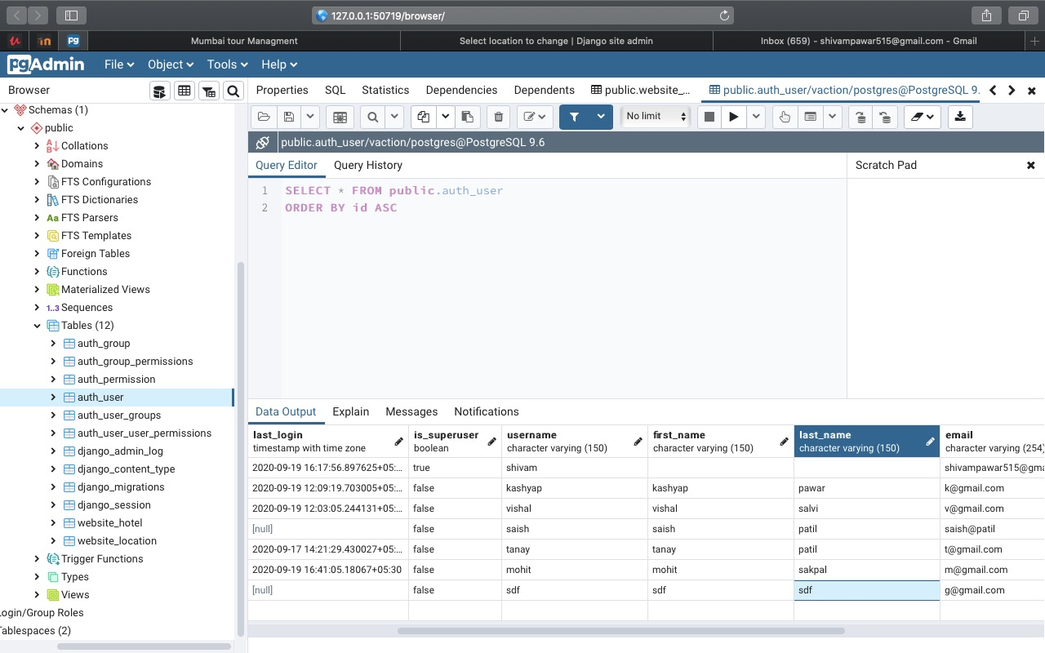

**Conclusion**: Thus, we implement mini project web application by using Django Framework also learn the authentication and database connectivity by using PostgreSQL database in Django framework.